**GET FREE AZURE**

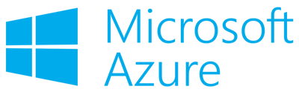

**In this session**

* Go to Visual Studio Dev Essentials
* Sign-in: If you already have Microsoft Account
* Create new: If you don't have Microsoft Account
* Check email and get the security code
* Login to Microsoft Live
* Verify security info
* Enter name, country and email address
* Confirm to join Dev Essentials
* Azure $25 monthly credit for 1 year
* Sign up for Developer Program Benefit
* Identity verification by phone
* Payment information
* Go to Try Microsoft Azure
* Sing-in account select

Go to Visual Studio Dev Essentials

https://www.visualstudio.com/dev-essentials/

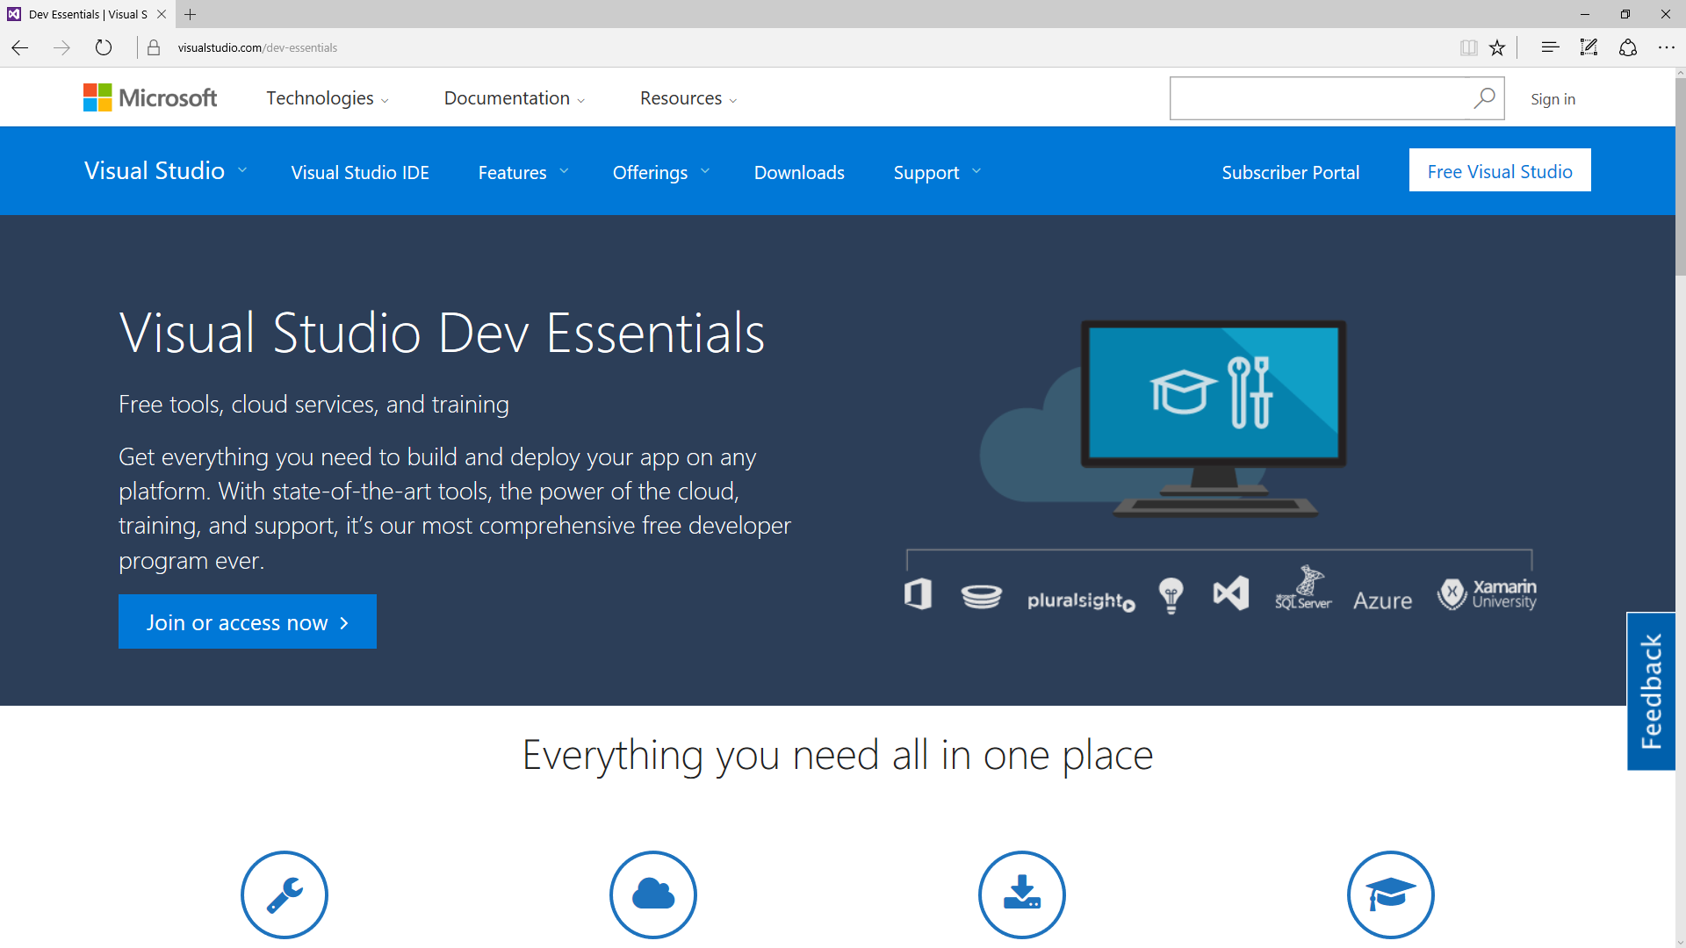

If you already have Microsoft Account

Enter email address & password / Click Sign in

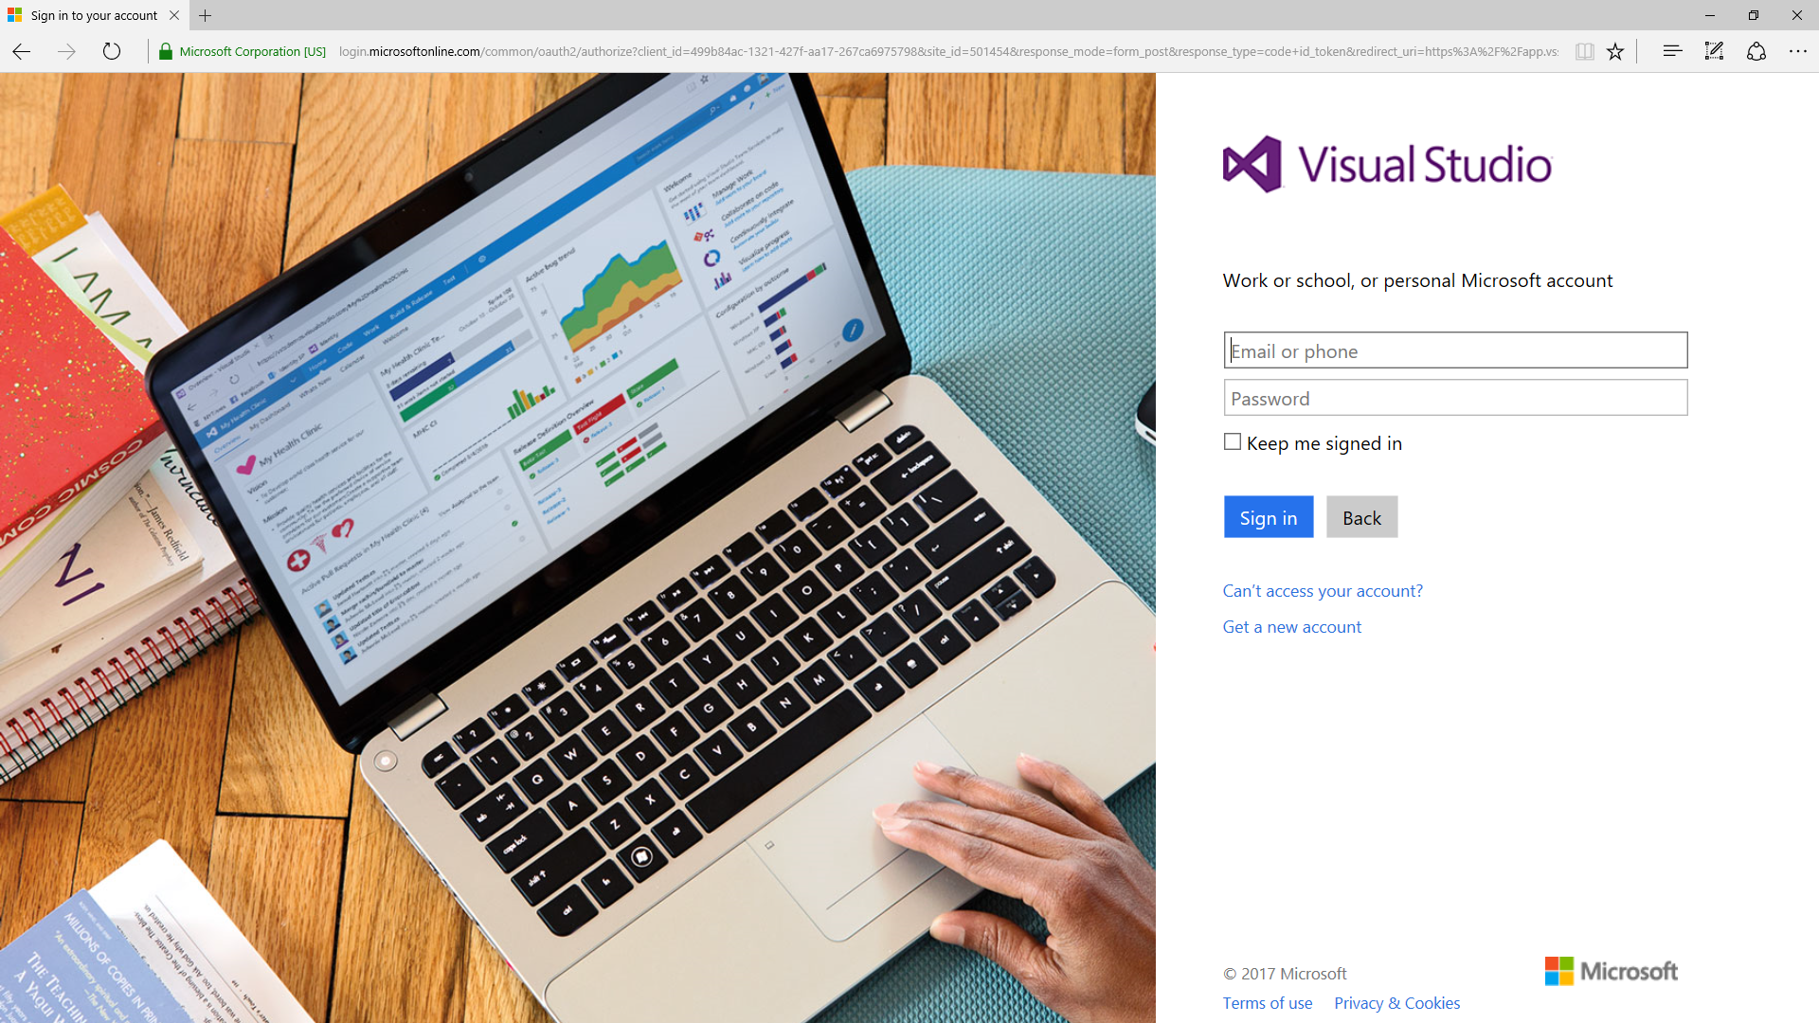

If you don’t already have Microsoft Account

Signup for a new Microsoft Account

https://signup.live.com

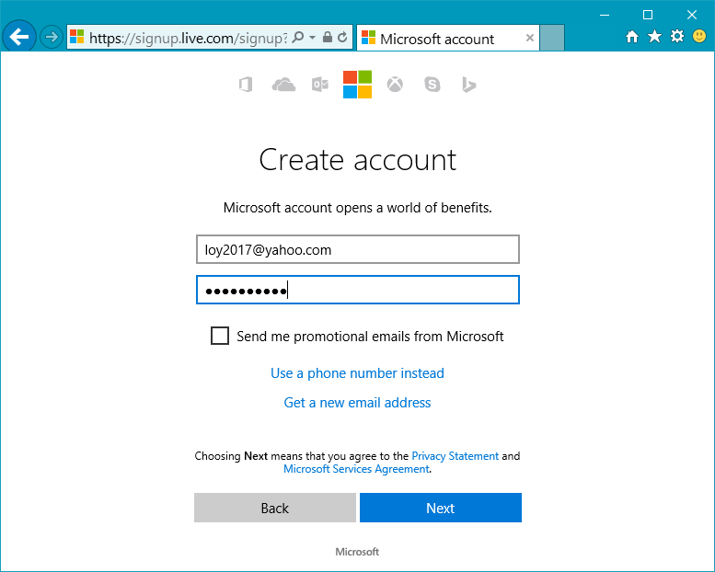

Verify email address

Check email and get the security code

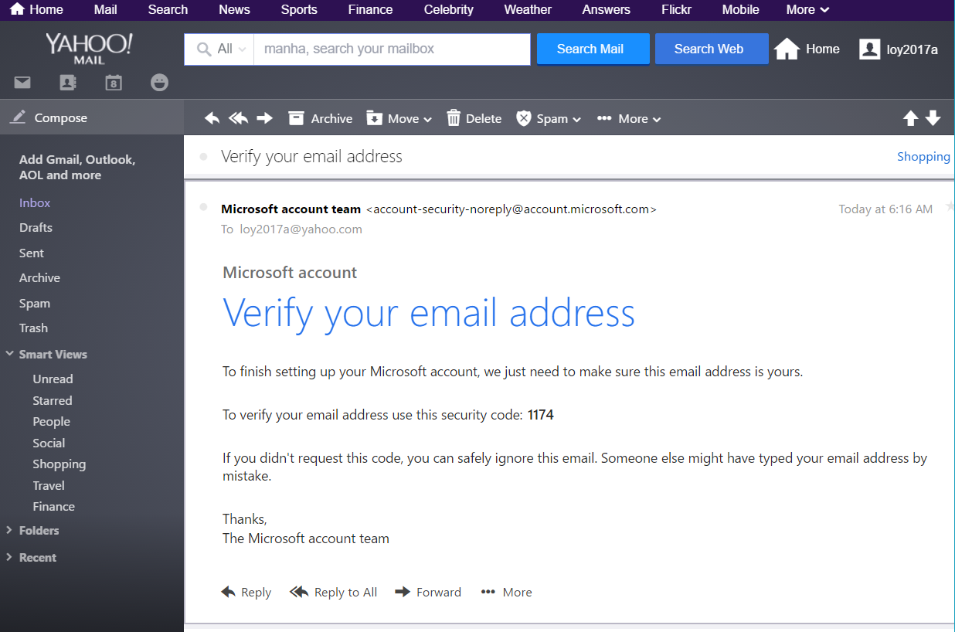

Login to Microsoft Live

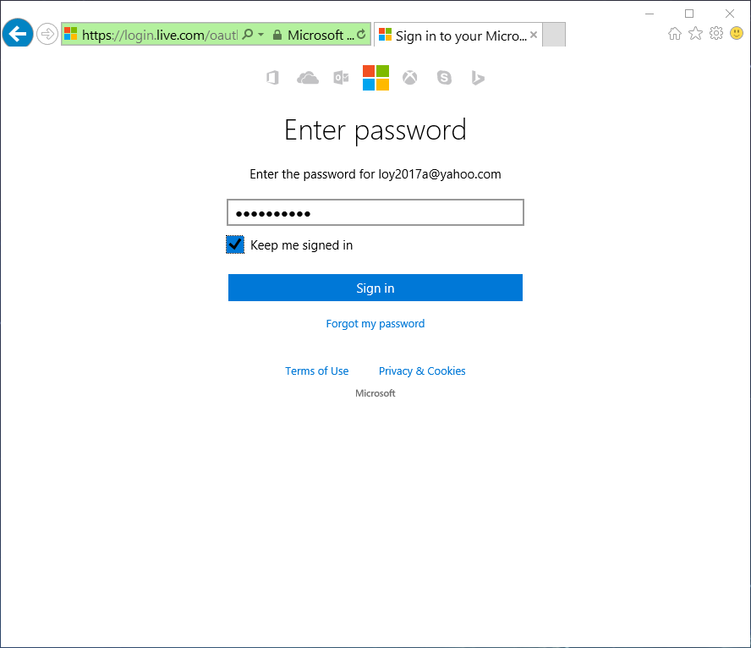https//login.live.com

Verify security info

Click Looks good!

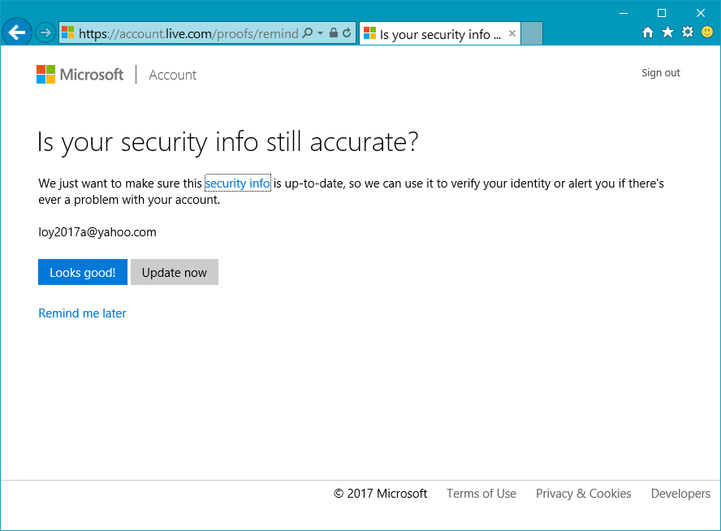

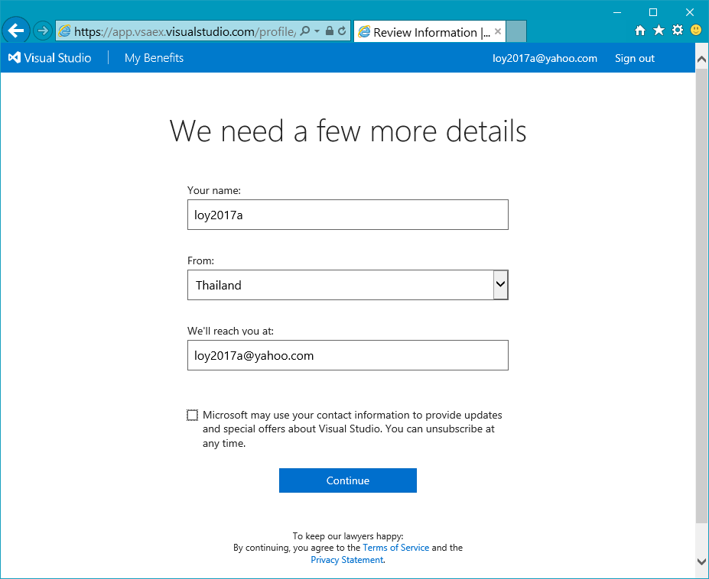We need a few more details

Enter name, country and email address

Accept the terms of the program

Click Accept

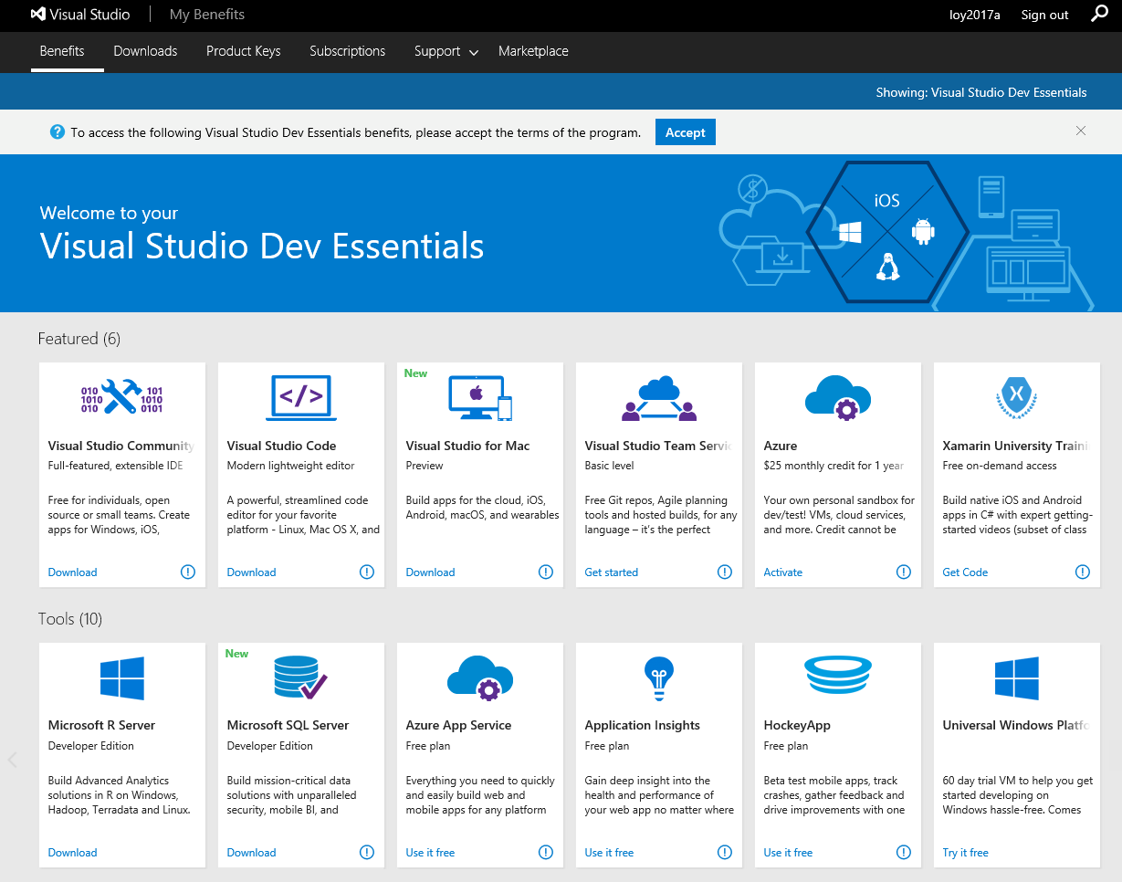

Confirm to join Dev Essentials

Click Confirm

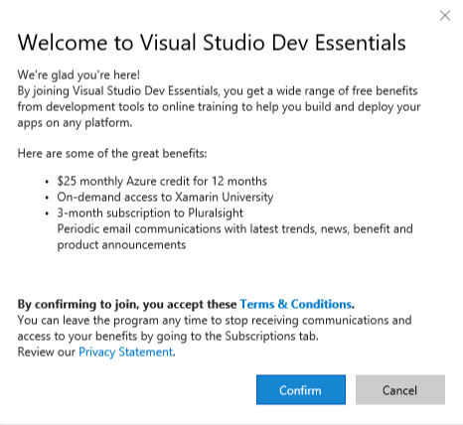

Azure $25 monthly credit for 1 year

Click Activate

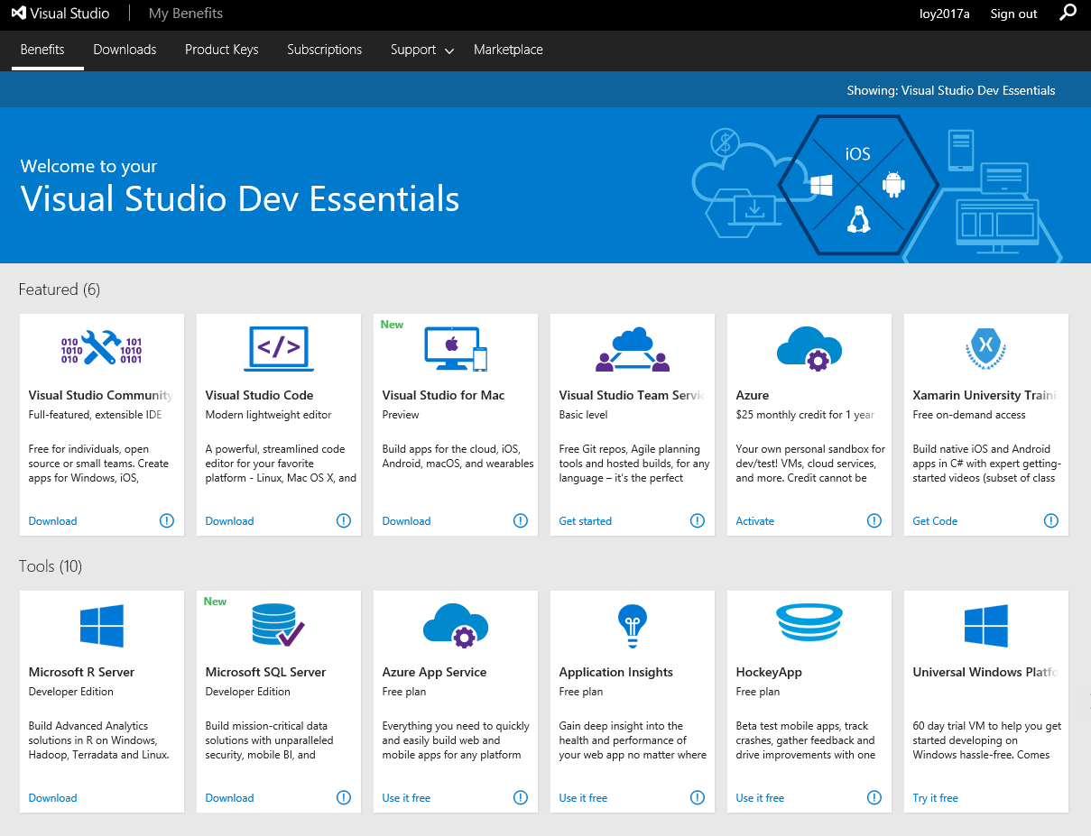

Sign up for Developer Program Benefit

Enter information and click Next

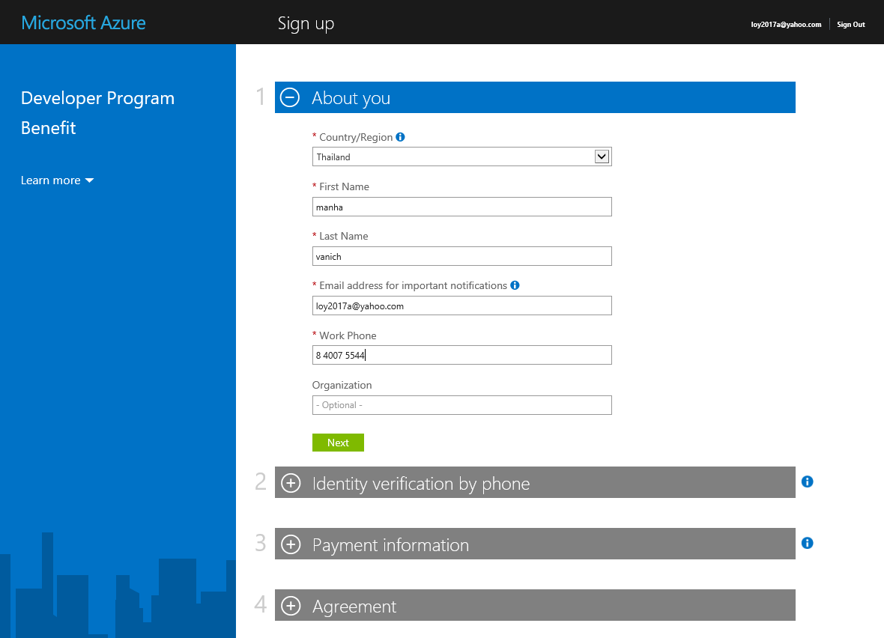

Identity verification by phone

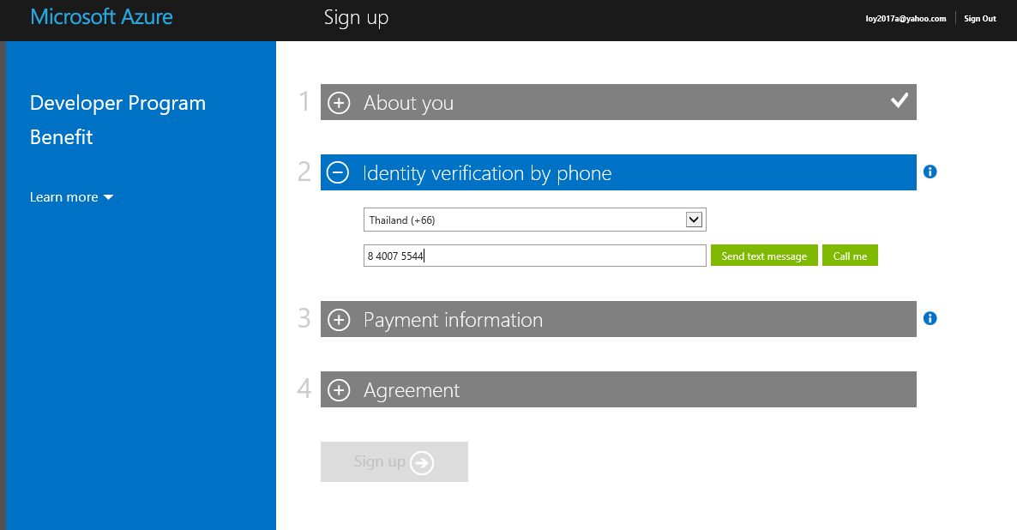Select country and enter phone number / Click Send text message

Identify verification by phone

Check phone SMS message / enter code / Click Verify code

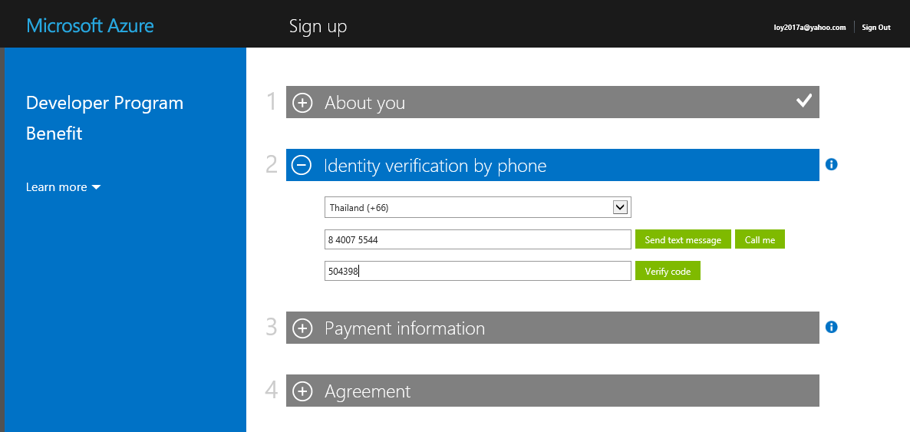

Payment information

Enter credit or debit card information / For identity (no charge)

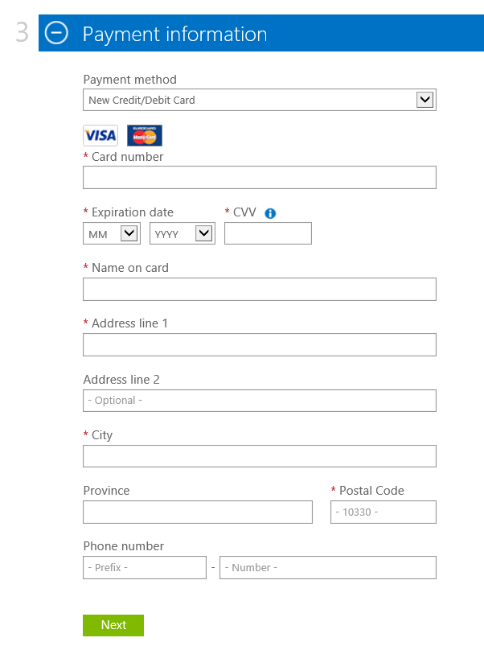

Go to Try Microsoft Azure

https://www.microsoftazurepass.com/azureu

Click Azure 30-day Free Trial

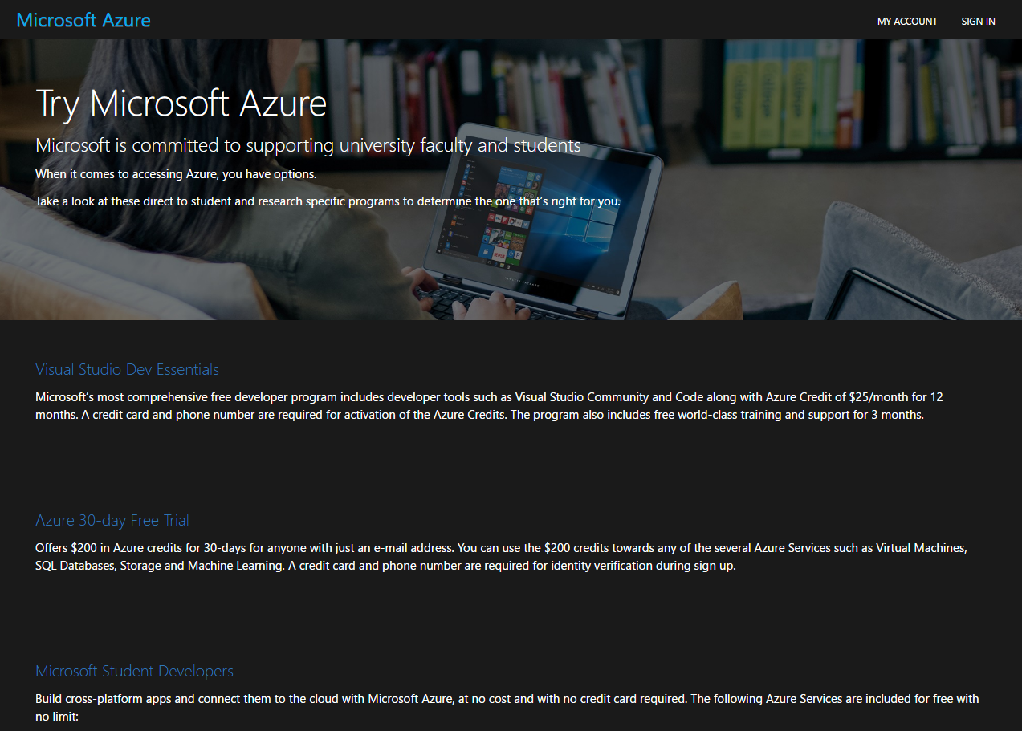

Create you free Azure account today

Click Start free >

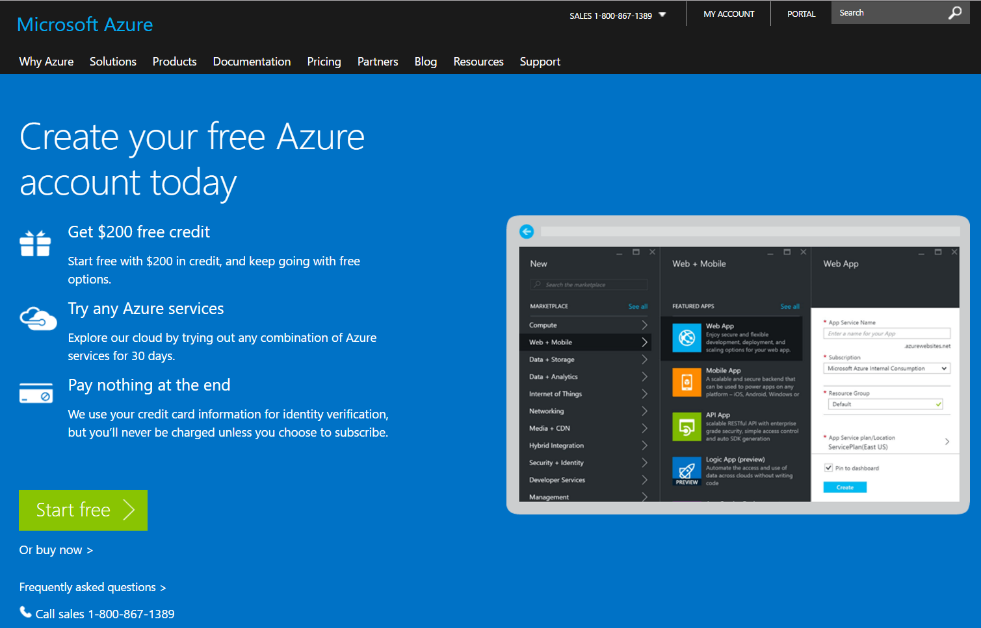

Sing-in account select

Click at the account to sign-in

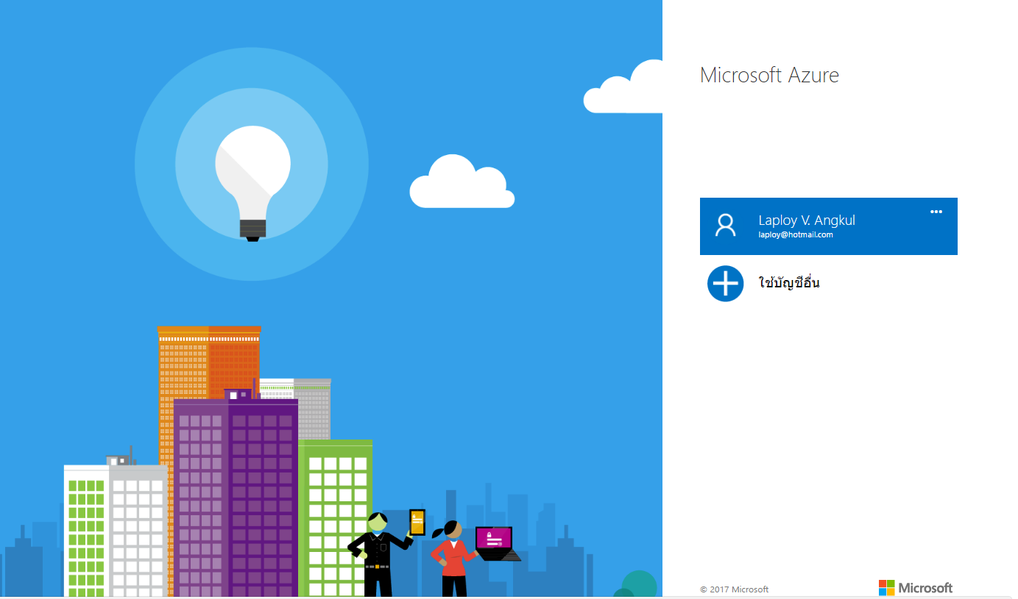

More information

**More information on Azure subscription**

Azure subscription and service limits, quotas, and constraints

https://docs.microsoft.com/en-us/azure/azure-subscription-service-limits